FALL PLANT SALE

PREORDER FORM
CMH Auxiliary is proud to partner with The Wild Rose. All proceeds benefit Community Memorial Hospital.

Name:______________________Phone Number:_______________

 | Description | Cost | Color | Qty | Total
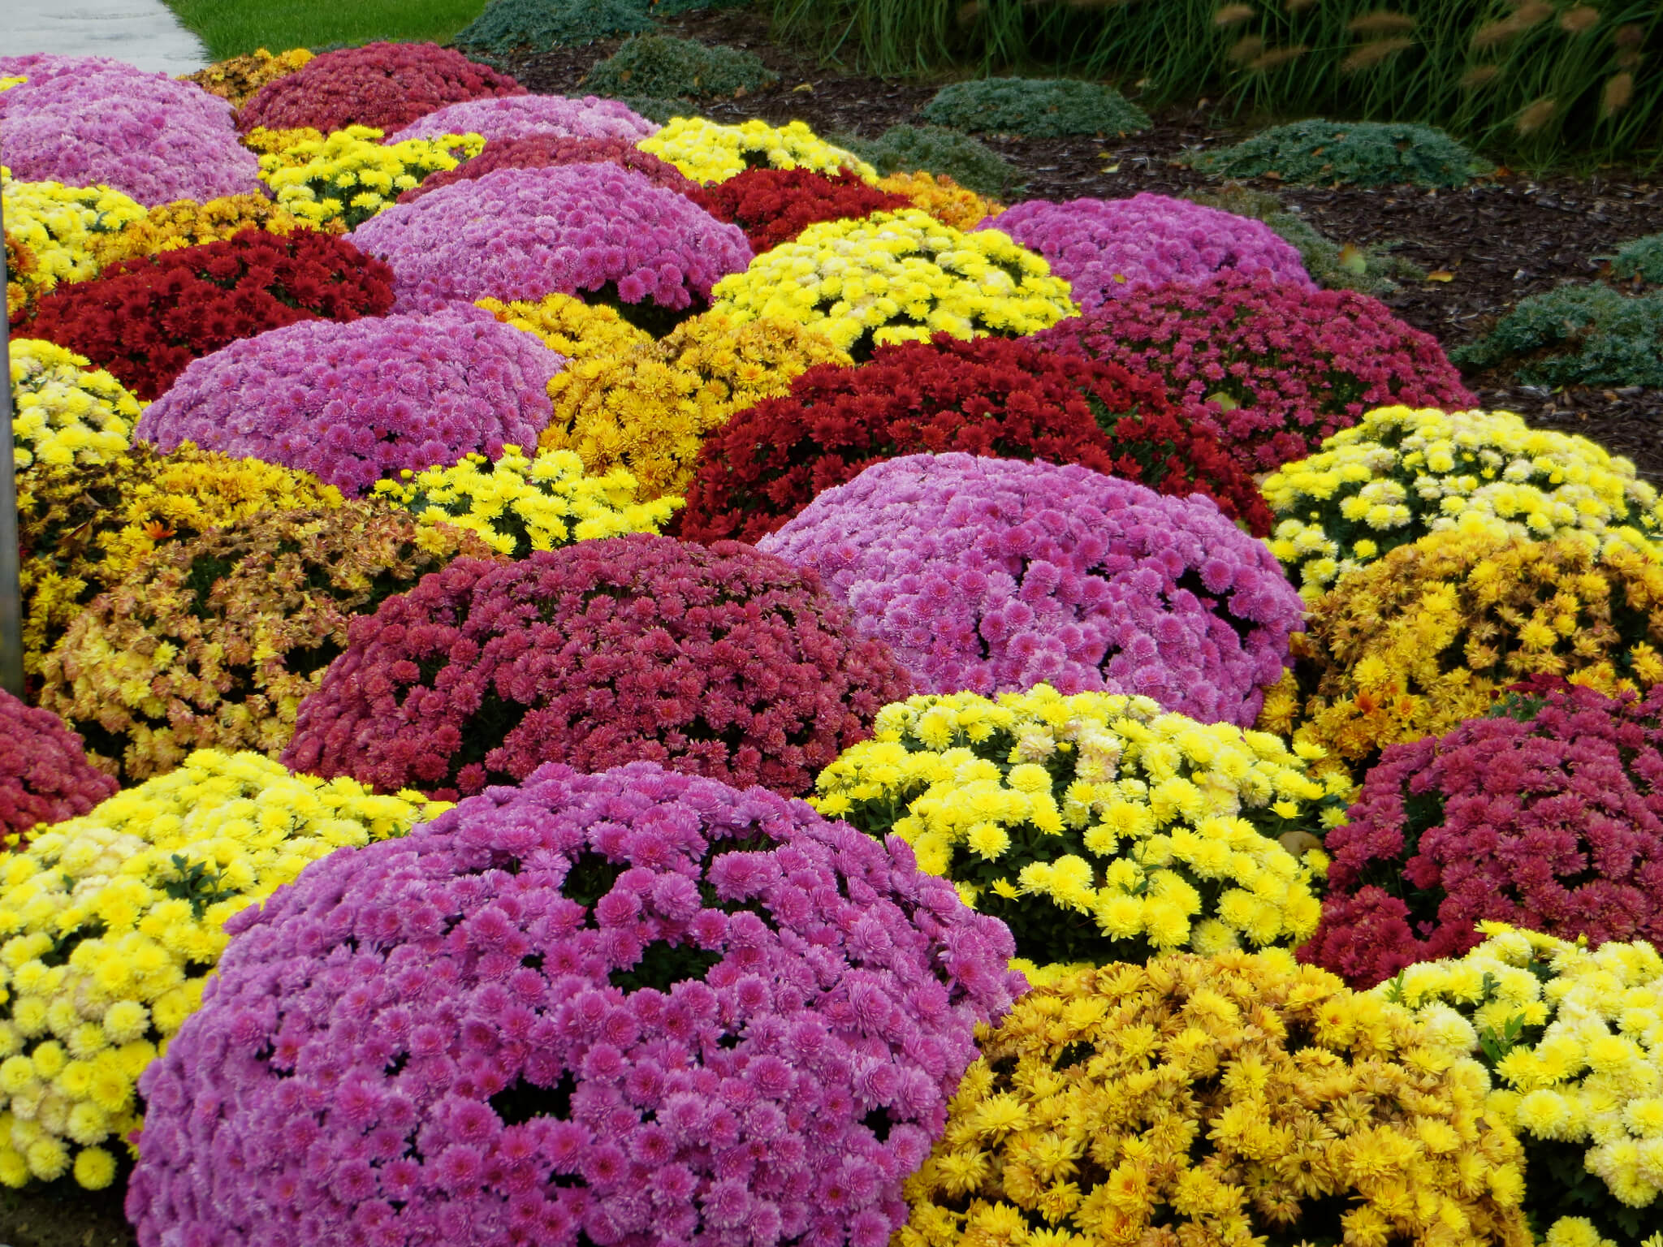 | Standard Mum - 9” pots | $17.50 | Red  Yellow  bronze Purple
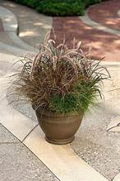 | Grass Mix 9” pots | $17.50
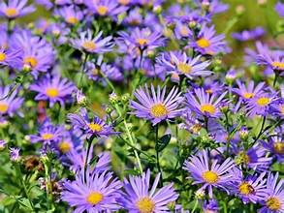 | Purple Asters 9” pots | $17.50
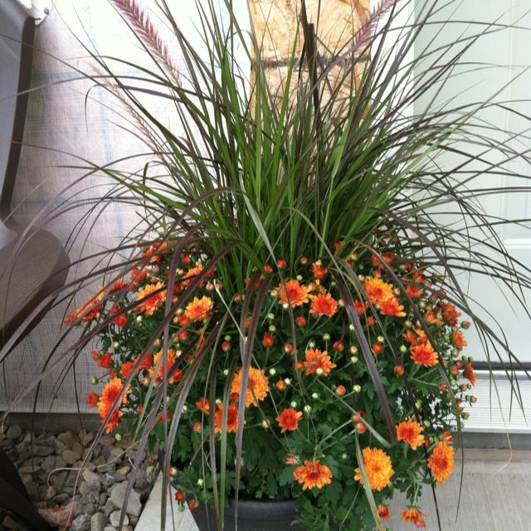 | Giant Mum w/or w/out Grass Mix (specify) | $49.99 | Yellow  orange  red  purple  tricolor
 | Tricolor Mum -10” pot | $22.00
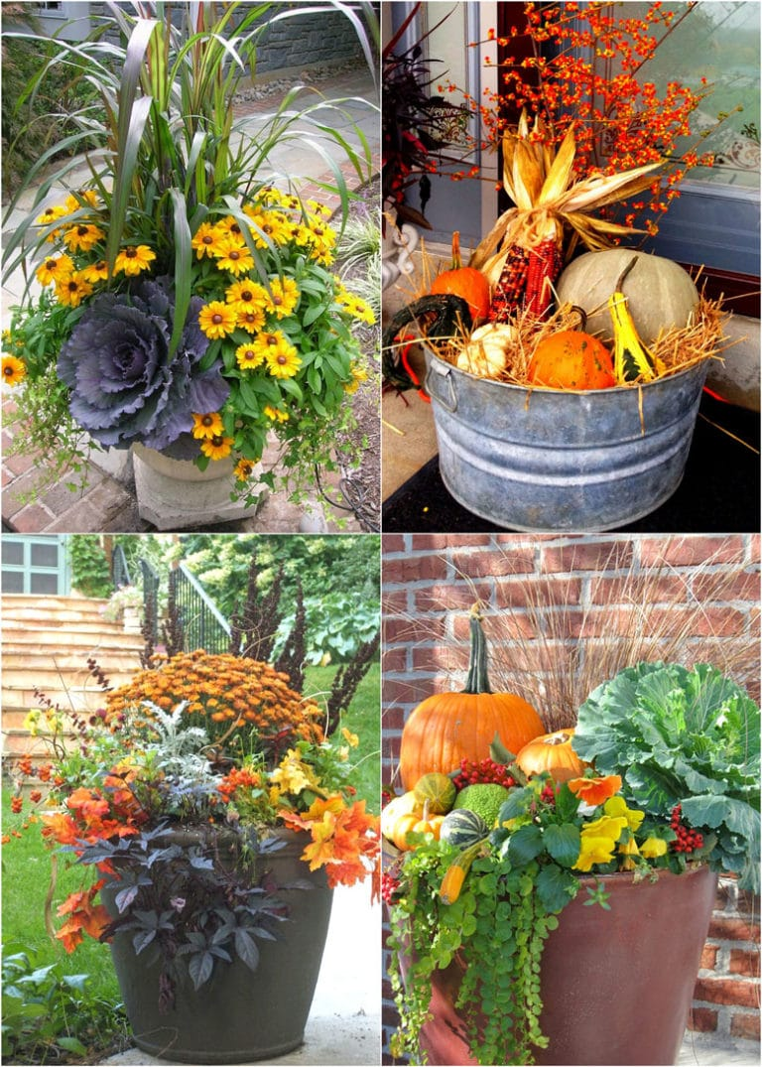 | Fall planter mix  Annuals with mum - 12” pots | $42.50
 | Rudbeckia - 12’ pot | $42.50
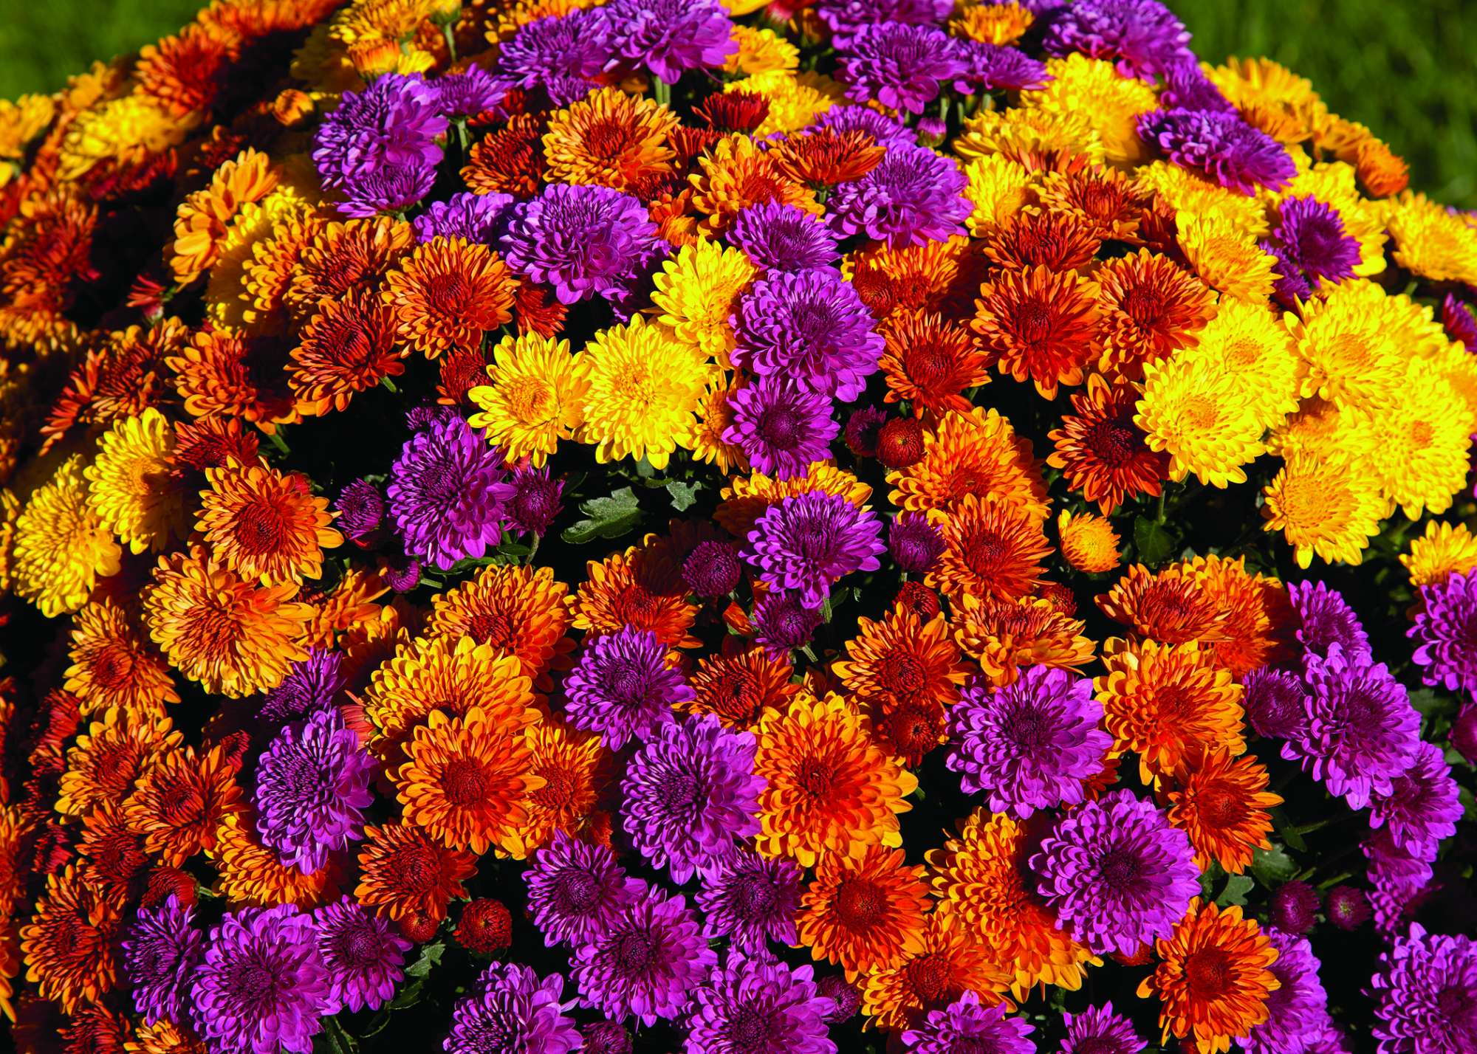 | Mixed Mums - 4.5” pot | $7.99 | No choice of color
 | Mixed mums - 6”pot | $10.99 | No choice of color

Return order forms and payment (cash or check made to CMH Auxiliary) to CMH by September 5,2025.
Questions call Pat Jungling at (319) 939-8061.

